**LAB 12**

Randomized quick sort is an extension of quicksort in which the pivot element is chosen randomly.

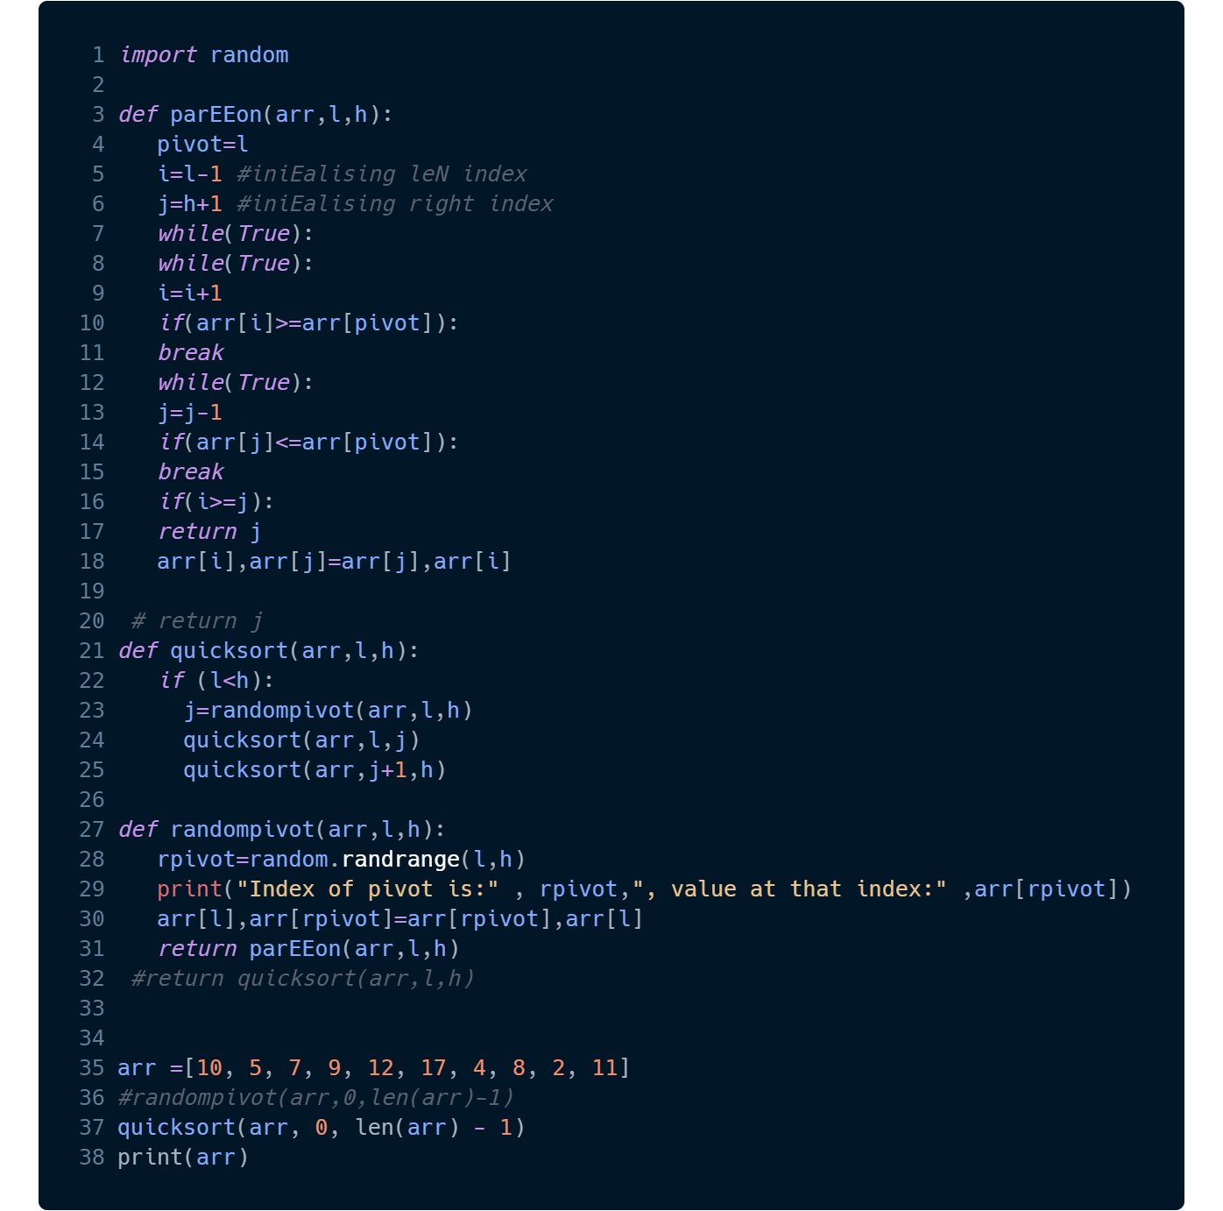

**Explanation:**

In this case, the pivot has been selected by using the "random" function. First, the index position 6 with value 4 has been chosen as the index. So, the first element i.e. 10 is swapped with 4. So the new array now is [4, 5, 7, 9, 12, 17, 10, 8, 2, 11]. Now the value of arr[i] is 4 and arr[j] is 11. Now, as i moves ahead in one iteration, j also moves to 2. Now, 5 and 2 are swapped. Now, the process is continued until j crosses i. In quicksort, the new position of j is swapped with the pivot element. Now, the next pivot element is 7 and the same process is repeated.